A Versatile Cryptocurrency Tracker Web Portal

Vivek Kumar Sharma

*Department of Computer Science KIET Group of Institutions*

Delhi-NCR, Ghaziabad Uttar Pradesh, India

[vivek.sharma@kiet.edu](mailto:vivek.sharma@kiet.edu)

Akanksha Mishra

*Department of Computer Science KIET Group of Institutions*

Delhi-NCR, Ghaziabad Uttar Pradesh, India

[akanksha.2024cs1126@kiet.edu](mailto:akanksha.2024cs1126@kiet.edu)

Anshul Sharma

*Department of Computer Science KIET Group of Institutions*

Delhi-NCR, Ghaziabad Uttar Pradesh, India

[anshul.2024cs1014@kiet.edu](mailto:anshul.2024cs1014@kiet.edu)

Anushraya Sharma

*Department of Computer Science KIET Group of Institutions*

Delhi-NCR, Ghaziabad Uttar Pradesh, India

[anushraya.2024cs1045@kiet.edu](mailto:anushraya.2024cs1045@kiet.edu)

***Abstract*—As we know cryptocurrency investments have surged in popularity, but the decentralized nature of the market poses challenges in accessing reliable information. To overcome this challenge this paper introduces the “Cryptocurrency Analysis WebApp”, a web-based platform offering essential data and live trends for top cryptocurrencies like Ethereum (ETH), Bitcoin (BTC), and Dogecoin (DOGE) etc. in one centralized location. This paper highlights the webapp’s versatile applications across financial markets, industries, and investment sectors, offering centralized information, historical performance analysis, and reliable predictions.**

**Keywords—Cryptocurrency tracking, online web portal, profitable investments, real-time data, market trends.**

1. INTRODUCTION

A web portal is a platform that collects information from various sources and integrates them into a single page for easy access. This enables users to receive tailored information based on their individual needs. Developing such portals offers numerous advantages for companies and organizations.

Portals serves as collection of resources, not only storing content and user specific data but the cryptocurrency portal is the online platform that allows investors and new comers to explore trending cryptocurrencies, compare them, and make profitable investments. The web portal offers a range of features, including the real-time cryptocurrencies price fluctuations and the ability to add desired cryptocurrencies to a watchlist for notifications. It allows users to access centralized real-time crypto information anytime, and anywhere.

Existing portals lack the ability to provide comprehensive cryptocurrencies data in real-time in different currencies as well as integrated wallet feature, making this platform a valuable addition. Furthermore, there is a need for a well-established framework to enhance user experience.

This research aims to define an improved framework for crypto analysis. It extends the current cryptocurrency portals to help individuals navigate the crypto world, make informed investment decisions, and gain valuable insights.

By bridging the gap left by existing portals, our framework empowers users with real-time access to comprehensive cryptocurrency data, enabling more informed investment decisions.

The enhanced framework aspires to become a one-stop solution for crypto-enthusiasts, offering not only up-to-the-minute market data but also news resources to support users in understanding the dynamics of cryptocurrency trading.

This research endeavors to create a robust and user-centric cryptocurrency analysis framework that simplifies the complexities of the crypto market.

1. LITERATURE REVIEW

Over the past nine years i.e., from 2013 to 2021, there have

been an increased no. of contributions in the cryptocurrency

trading publications. The statistics, published in Fang et al.

Financial Innovation Journal in 2022 [1]. Figure1 shows

statistical data of cryptocurrency trading publications.

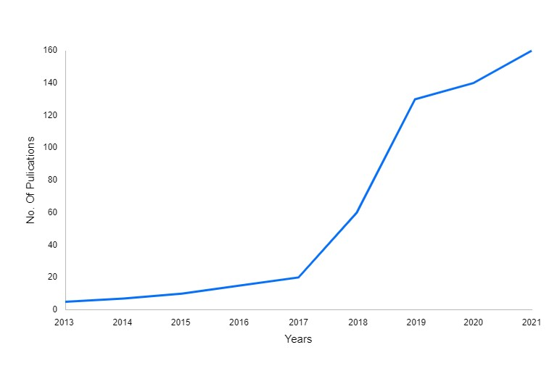

Figure.1. Published Article in Fang et al. Financial Innovation [2013-2021]

Figure 2 (Trading View 2022) displays historical statistics on 24-hour trading volume and worldwide market capitalization. The whole market capitalization for cryptocurrencies is shown by the blue line, while the total market volume is represented by the green/red histogram.

The chart shows how cryptocurrencies grew exponentially in 2017 and saw a significant bubble bust in the beginning of 2018. 2020 saw a sharp increase in the value of cryptocurrency following the epidemic. The value of cryptocurrencies has fluctuated greatly in 2021, yet it has continuously remained at historically high levels [1].

Building on the literature analysis and emphasizing the need to look at consumer behavior when it comes to cryptocurrencies, the authors offer a thorough methodological strategy that is depicted in Figure 3. The whole mapping of the approach's investigated process is displayed in Figure 3. The methodology of the study is predicated on prospective visitors to bitcoin websites, the routes they take to get at such websites, and the ways in which their actions impact the digital marketing procedures of cryptocurrency firms. A prospective client need to access a bitcoin website using a desktop computer or a mobile device. There are five distinct methods to access bitcoin websites from each device: direct, referral, search, social, and sponsored traffic. Customers engage with the website after they land on it, leaving their distinct behavioral pattern behind. These trends (device preference, traffic source, and website behavioral analytics) might be used by cryptocurrency companies to improve their digital marketing effectiveness and eventually boost their profitability [2].

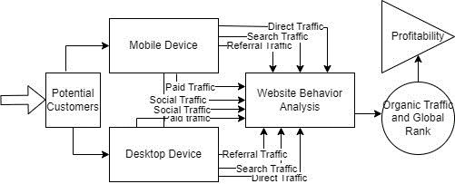

Figure.3. Conceptual Framework of Cryptocurrency Websites

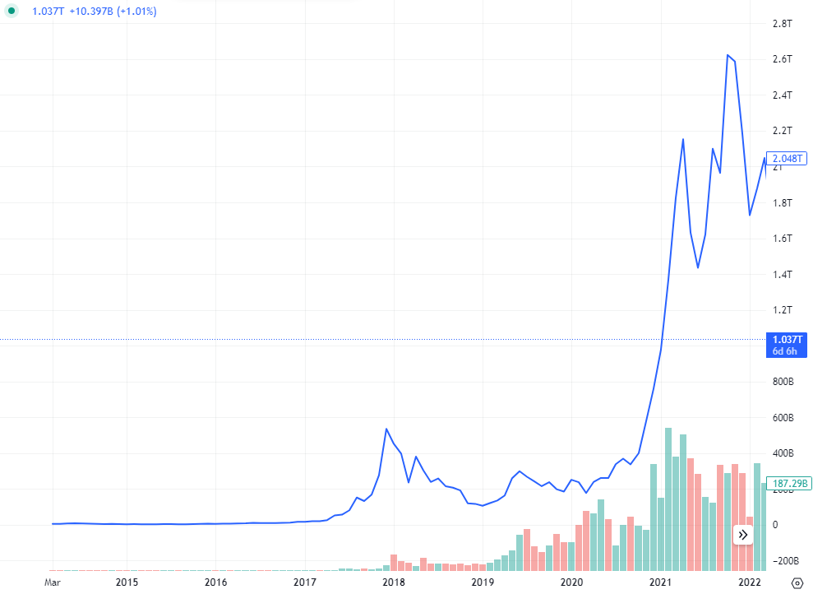 III. DIFFERENCE BETWEEN CRYPTO TRANSACTION

AND BANK TRANSACTION

Banks, as traditional finance institutions, operate under government regulations and oversight. In contrast, cryptocurrencies are decentralized and does not require government backing. This fundamental distinction is one of the key factors driving the preference for cryptocurrency transactions over traditional bank transactions.

One notable advantage of cryptocurrencies is their resilience against single points of failure, a vulnerability that banks occasionally encounter. This resilience enhances the trust individuals place in cryptocurrency transactions. Unlike traditional banking, cryptocurrency transactions are peer-to-peer, eliminating the need for intermediaries like banks. This direct method of transfer minimizes transaction costs and simplifies the process.

Moreover, while government supervision can impose restrictions on certain bank transactions, cryptocurrencies operate outside the purview of government oversight. This autonomy allows users to engage in peer-to-peer transactions without regulatory interference, offering a level of financial freedom that traditional banking cannot match. Cryptocurrency transactions are seamlessly linked to transaction IDs on the blockchain rather than being tied to individual bank accounts within a financial institution.

The decentralized and government-independent nature of cryptocurrencies, coupled with their resilience against single points of failure and peer-to-peer transaction capabilities, make them an appealing choice for individuals seeking efficient and unrestricted financial transactions.

Figure.2. Total market capitalization and volume of cryptocurrency market, USD (Trading View 2022)

CRYPTOCURRENCY TRACKER APP ARCHITECTURE

1. *FrontEnd*

*User Interface*

The cryptocurrency tracker app's User Interface (UI), which offers a visually intuitive and interactive experience, acts as a link between users and the underlying technology. The user interface (UI) guarantees accessibility on a range of devices thanks to its responsive design. Real-time pricing displays, programmable charts, and intuitive navigation are essential elements. Candlestick charts and trend indicators are two examples of data visualization tools that make thorough market analysis easier. User interactions are supported by the UI, making it easy to access features like portfolio management, historical data exploration, and customized settings. The user interface (UI) attempts to increase user engagement by offering a simple and intuitive design that makes it easy for users to track cryptocurrency trends and make well-informed investment decisions.

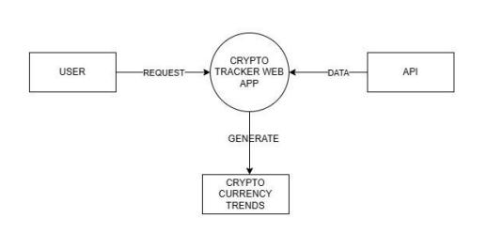

Figure.3. Data Flow Diagram Level 0

*Data Visualization*

The cryptocurrency tracker app's data visualization is essential for breaking down complex market data into insights that can be put to use. It makes use of many graphs, charts, and heatmaps to make it easy for users to understand historical patterns, trading volumes, and price trends. Line charts show more general patterns, whereas candlestick charts show more in-depth price changes. Users can customize their data views for individualized analysis by zooming, panning, and using dynamic functions. With a clear, educational, and intuitive interface, this visualization powerhouse gives users the capacity to better understand and traverse the intricate dynamics of cryptocurrency markets for well-informed decision-making and strategic planning.

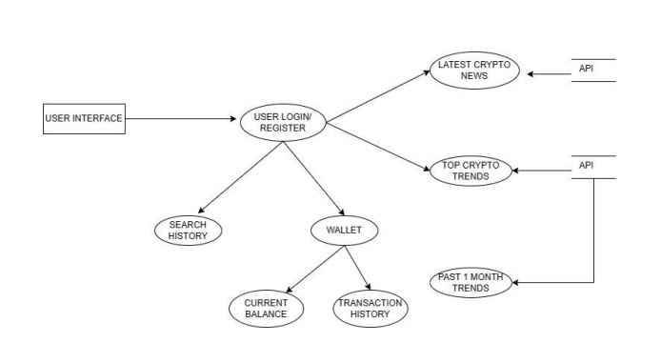

Figure.4. Data Flow Diagram Level - 1

1. *BackEnd*

The bitcoin tracker app's backend consists of a strong server, an intricate database, and flawless API connectivity. In addition to processing user requests and carrying out business logic, the server also connects to other bitcoin APIs to receive real-time data updates. Ensuring data integrity and accessibility, the database holds user information, historical market data, and other crucial records. Real-time bitcoin pricing and related data can be retrieved more easily with API connectivity. Optimizing performance and data reliability while supporting the overall functioning of the application is ensured by utilizing a secure and scalable backend architecture. The backend plays a crucial role in enabling the app's responsiveness and providing users with accurate and current information.

1.Server

The Cryptocurrency tracker app's server handles user requests, carries out business logic, and makes sure that external APIs are communicated with without a hitch. Using an effective server architecture is crucial for real-time updates and responsiveness, which improves the app's overall performance and dependability.

2.Database

A cryptocurrency web app's database serves as the central store for user data, market data, and application settings. Its efficient management and structure, powered by an appropriate database system, guarantees data accessibility and integrity and provides users and researchers with the necessary functionality.

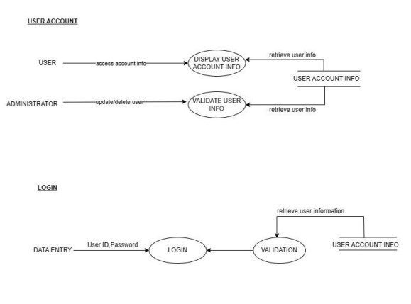

Figure.5. Data Flow Diagram Level -2

1. *API Integration*

An essential feature of any cryptocurrency research web software is API integration, which offers easy access to current market data. The dynamic and rapid dynamics of bitcoin markets necessitate the provision of precise and timely information. By connecting the app to external exchanges via APIs, users may instantly access historical data, current market trends, and real-time price updates. The creation of machine learning models for predictive analysis, algorithmic trading techniques, and advanced analytics are all made easier by this connection.[4] In the realm of research, API integration makes it possible for academics and researchers to quickly collect, process, and analyze data, facilitating in-depth investigations into investor mood, market behavior, and general cryptocurrency trends. A research-focused bitcoin web app's reliance on APIs is essential for generating trustworthy, current, and insightful data for scholarly and analytical endeavors.

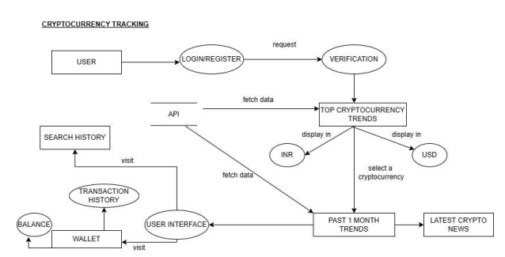

Figure.6. Data Flow Diagram Level - 2

1. PROPOSED APPROACH

The study paper's suggested methodology centers on creating an extensive bitcoin tracker web application. With a responsive and aesthetically pleasing interface, the frontend design will prioritize the user's experience, enabling users to easily navigate and track different cryptocurrencies. The user interface (UI) will offer real-time updates on price trends, historical data, and customized portfolio insights by utilizing contemporary charting libraries. Robust server design on the backend will manage user requests, carry out business logic, and keep efficient contact with third-party bitcoin APIs. In order to guarantee that the app provides precise and timely market information, this integration is essential. User profiles, historical data, and app configurations will all be safely stored in a database that is arranged using an appropriate database management system, guaranteeing data accessibility and integrity.[5] Although the web application is the main focus, it will be crucial to guarantee cross-browser compatibility and good performance. To protect user information, strict security measures will also be prioritized, such as HTTPS for secure communication and encryption for sensitive data. The goal of this suggested strategy is to offer a research-useful, dependable, and safe cryptocurrency tracker web app. Focusing on security, usability, and usefulness, the proposed online application will be a useful resource for scholars investigating the complex relationships between different cryptocurrencies.

1. Functions Of Portal
2. User Registration and Login: Researchers can have personalized accounts for a tailored experience and data management thanks to secure user authentication.
3. Real-Time Price Tracking: This feature allows researchers to observe the market in real-time by continuously monitoring and displaying real-time bitcoin prices.[5]
4. Historical Data examination: Researchers can examine market trends and patterns over particular time periods with the use of strong tools for in-depth examination of historical price data.
5. Customized Portfolio Management: This feature helps researchers keep track of their investments and performance by enabling users to establish, modify, and maintain private cryptocurrency portfolios.
6. Wallet Monitoring: This feature enables users monitor their holdings and transaction history for research purposes by allowing them to check their bitcoin wallets.
7. Advanced Data Visualization: During research, difficult market data can be made easier to understand and analyze by utilizing advanced data visualization techniques like interactive charts and graphs.[4]
8. News and Events Integration: Integration of real-time news feeds and events relevant to the cryptocurrency market, offering researchers contextual information that may impact their analyses*.*

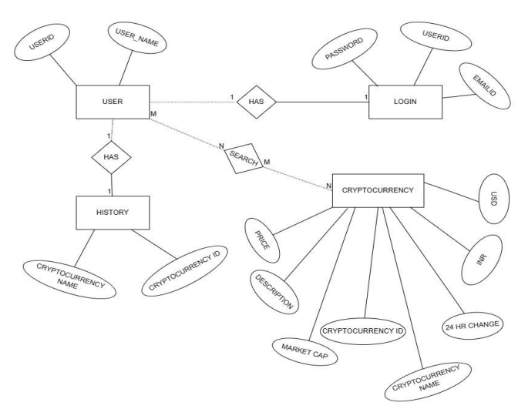

Figure –7 : Entity Relationship Diagram

1. RESULT AND DISCUSSION

Promising results were obtained from the creation and deployment of the Cryptocurrency Tracker Web App, demonstrating its effectiveness in offering a thorough platform for cryptocurrency fans and academics. Important outcomes consist of

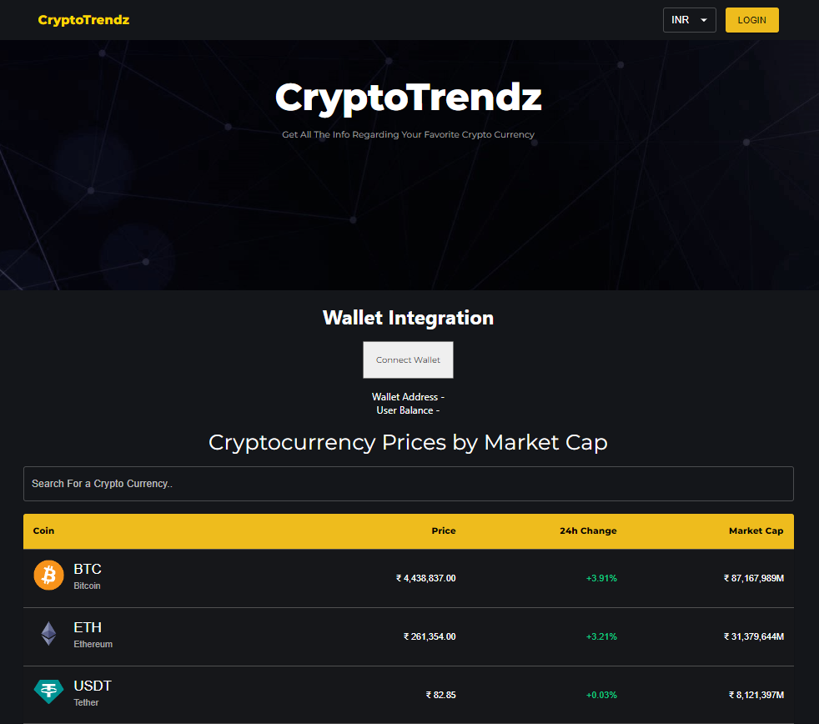

Figure-8. Crypto Currency Tracker Website UI

1. Accurate Real-Time Price Data: Derived from dependable external APIs, the app regularly provided real-time cryptocurrency prices. By comparing the data with several market sources, the accuracy of the information was confirmed.

2. User Registration and Authentication: The implementation of user registration and authentication procedures was accomplished with success, guaranteeing safe access to customized features.[9] Security and user data integrity protocols have undergone extensive testing and shown to be successful.

3. Portfolio Management Tools: Users were able to create, update, and analyze their bitcoin portfolios with ease thanks to the adaptable portfolio management tools. Increased control over their investments was reported by users.

4.Historical Data Analysis: Comprehensive study into market patterns and behavior was made easier by the app's historical data analysis features. The approach proved to be highly intuitive and beneficial for researchers carrying out extensive investigations.

5. Advanced Data Visualization: Interactive graphs and charts were among the features that users found appealing in the advanced data visualization section. User experience was enhanced overall, as evidenced by feedback highlighting improved interpretability and clarity.

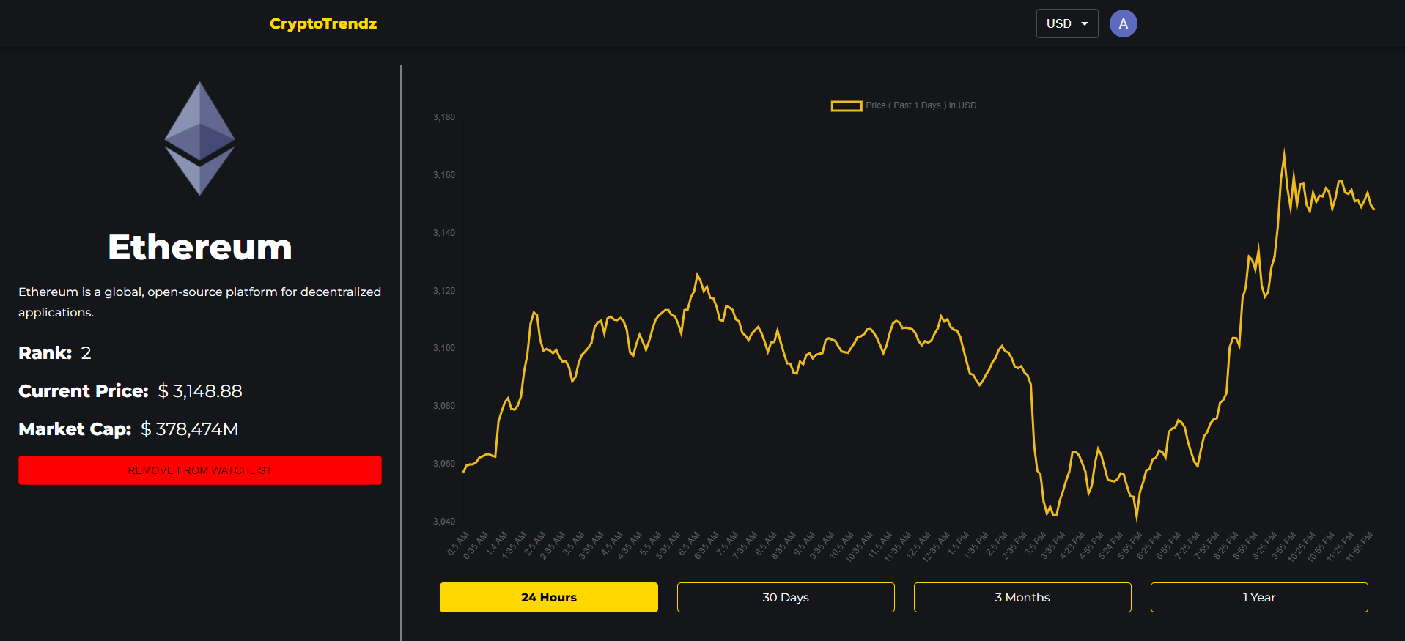

Figure -9. Crypto Currency Tracker Web Graphs

6. News and Events Integration: It has been effective to provide consumers with the most recent contextual information by integrating real-time news feeds and events. It was determined that this feature was a useful tool for figuring out how the market felt.

7. API incorporation for Research Automation: Users were able to automate data retrieval, which made algorithmic analyses easier and supported the incorporation of machine learning models.[10] This was made possible by the smooth interaction with external APIs. Researchers observed that automation increased accuracy and efficiency.

8. Wallet Check: By including a wallet check feature, customers can now effortlessly keep an eye on and manage their bitcoin holdings. Positive comments about this feature's accessibility and convenience were received.

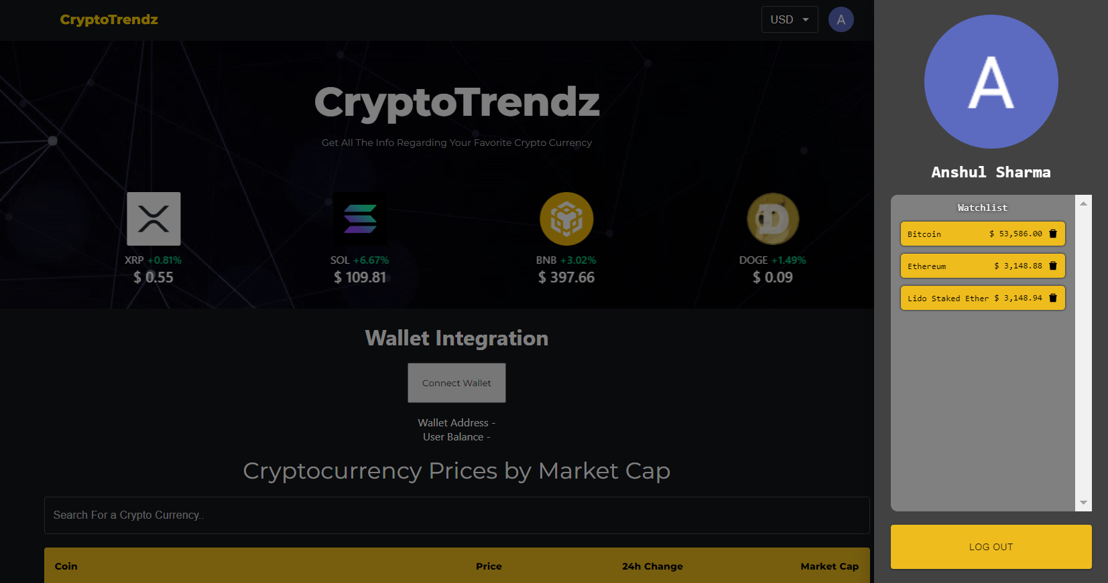

Figure 10. Wallet Integration in CryptoCurrency Tracker WebApp

The Cryptocurrency Tracker Web App is a useful resource for researchers and fans alike because of its ability to provide real-time, historical, and customized cryptocurrency data. A smooth research experience is enhanced by the sophisticated features combined with an intuitive UI. For the app to continue to be relevant in the changing cryptocurrency ecosystem, it is imperative that user input be integrated into its development and that it receives ongoing enhancements. [6] As the app's features are continuously improved and expanded, future study may look at new features, user interaction techniques, and possible integrations. All things considered, the findings validate the usefulness of the Cryptocurrency Tracker Web App in offering a stable and user-friendly platform for tracking and investigations into cryptocurrencies.

1. CONCLUSION AND FUTURE WORK

In conclusion, by offering consumers precise real-time cryptocurrency values, reliable user identification procedures, and a variety of useful portfolio management and analysis capabilities, the Cryptocurrency Tracker Web App has effectively met its goals. Its usefulness and relevance are highlighted by the favorable response to its news integration and sophisticated data visualization tools. The success of the program may be attributed to its flexibility and user-centric design, which establish it as a useful tool for academics and cryptocurrency enthusiasts to navigate the ever-changing world of digital assets. Subsequent development of the Cryptocurrency Tracker Web App will concentrate on ongoing improvement, investigating new API integrations for wider coverage, and utilizing cutting-edge machine learning models for predictive analysis. [8] Social sentiment analysis tools and partnerships for carefully chosen instructional content are two potential changes that might be made in response to user input. The app's development will be governed by a dedication to innovation, guaranteeing its continued efficacy in satisfying users' changing demands in the volatile cryptocurrency market.

REFERENCES

1. McMillan, R. (2014, March 3). The Inside Story of Mt. Gox, Bitcoin‟s $460 Million Disaster. Retrieved from Wired.com Website: http://www.wired.com/2014/03/bitcoin-exchange/
2. Patterson, J. (2015, August 04). Bitcoin: A New Global Economy. Retrieved from Bitpay Website: https://blog.bitpay.com/bitcoin-a-new-global-economy/
3. Team, B. (2016, January 20). Understanding Bitcoin's Growth in 2015. Retrieved from Bitpay Website: https://blog.bitpay.com/understanding-bitcoins-growth-in-2015/
4. Nakamoto, S. (2008). Bitcoin: A Peer-to-Peer Electronic Cash System. Retrieved from https://bitcoin.org/bitcoin.pdf
5. Antonopoulos, A. M. (2014). Mastering Bitcoin: Unlocking Digital Cryptocurrencies. O'Reilly Media.
6. Swan, M. (2015). Blockchain: blueprint for a new economy. O'Reilly Media.
7. Zohar, A. (2015). Bitcoin: under the hood. Communications of the ACM, 58(9), 104-113. doi: 10.1145/2817191.
8. Fantazzini D, Zimin S (2020) A multivariate approach for the simultaneous modelling of market risk and credit risk for cryptocurrencies. J Ind Bus Econ
9. Feinstein BD, Werbach K (2021) The impact of cryptocurrency regulation on trading markets. Journal of Financial Regulation .
10. Narayanan, A., Bonneau, J., Felten, E., Miller, A., & Goldfeder, S. (2016). Bitcoin and Cryptocurrency Technologies: A Comprehensive Introduction. Princeton University Press